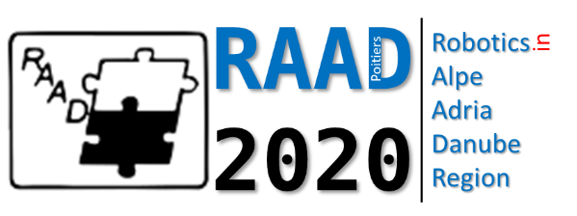

The 29th International Conference on Robotics in Alpe-Adria-Danube Region, (RAAD’2020)
June 17-19, 2020
Futuroscope-Poitiers, France

Special Session on

{include the name of the special session}

Special Session Organizers (names and contact emails):

Technical Outline of the Session (50 words) and Topics:

Potential Contributing Authors (names and emails):

Potential Reviewers (names and emails):

